PROFESSIONAL TRAINING REPORT
at
Sathyabama Institute of Science and Technology (Deemed to be University)

Submitted in partial fulfillment of the requirements for the award of Bachelor of Engineering Degree in Computer Science and Engineering

By
BALA DEEPIKA J
REG. NO. 39110112



DEPARTMENT OF COMPUTER SCIENCE ANDENGINEERING

SCHOOL OF COMPUTING

SATHYABAMA INSTITUTE OF SCIENCE AND TECHNOLOGY
JEPPIAAR NAGAR, RAJIV GANDHI SALAI,
CHENNAI – 600119, TAMILNADU

NOVEMBER 2021

 | SATHYABAMA  INSTITUTE OF SCIENCE AND TECHNOLOGY  (DEEMED TO BE UNIVERSITY)  Accredited with Grade “A” by NAAC  (Established under Section 3 of UGC Act, 1956)  JEPPIAAR NAGAR, RAJIV GANDHI SALAI  CHENNAI– 600119  www.sathyabama.ac.in |   

DEPARTMENT OF COMPUTER SCIENCE AND ENGINEERING

BONAFIDE CERTIFICATE

This is to certify that this Project Report is the bonafide work of BALA DEEPIKA J (Reg. No: 39110112) who carried out the project entitled “Concrete Strength Prediction” under my supervision from June 2021 to November 2021.

Internal Guide

Dr.A.C.Santha Sheela, MCA,ME.,Ph.D.,

Head of the Department

Dr. L. Lakshmanan, M.E., Ph.D.,

Submitted for Viva voce Examination held on

Internal Examiner External Examiner
DECLARATION

I, BALA DEEPIKA J hereby declare that the project report entitled Concrete Strength Prediction done by me under the guidance of Dr.A.C.Santha Sheela, MCA, M.E, PhD., submitted in partial fulfillment of the requirements for the award of Bachelor of Engineering Degree in Computer Science and Engineering.

DATE: BALA DEEPIKA J

PLACE: SIGNATURE OF THE CANDIDATE

ACKNOWLEDGEMENT

I am pleased to acknowledge my sincere thanks to Board of Management of SATHYABAMA for their kind encouragement in doing this project and for completing it successfully. I am grateful to them.

I convey my thanks to Dr. T. Sasikala M.E., Ph.D, Dean, School of Computing, Dr. S. Vigneshwari, M.E., Ph.D. and Dr. L. Lakshmanan, M.E., Ph.D., Heads of the Department of Computer Science and Engineering for providing me necessary support and details at the right time during the progressive reviews.

I would like to express my sincere and deep sense of gratitude to my Project Guide Dr. A.C.Santha Sheela, MCA, M.E., Ph.D., for her valuable guidance, suggestions and constant encouragement paved way for the successful completion of my project work.

I wish to express my thanks to all Teaching and Non-teaching staff members of the Department of Computer Science and Engineering who were helpful in many ways for the completion of the project.

TRAINING CERTIFICATE



ABSTRACT

In this study a mathematical model is proposed and developed using multivariate regression equation for the prediction of concrete compressive strength at different ages (e.g. 7 and 28 days). The variables used in the prediction models were from the knowledge of the mix itself, i.e. mix proportion elements (cement, water, aggregate, fly ash, etc.). The proposed model proved to be a major tool in predicting compressive strength of different concretes from a ready mix (RMX) plant in spite of variations in the results. The strengthening of concrete is a complex process involving many factors. A number of prediction techniques have been proposed by including empirical or computational modelling, statistical techniques and artificial intelligence approaches. Apart of its speed, statistical modeling has the advantage over other techniques that it is mathematically rigorous and can be used to define confidence interval for the predictions. Statistical analysis can also provide insights into the key factors influencing compressive strength through correlation analysis. There are many parameters of concrete that influence its strength gaining characteristics. This study is an attempt to use the early compressive strength test result to estimate compressive strength at different ages. Potential utilization of the early day compressive strength result to predict characteristic strength of normal weight concrete has been investigated. A simple mathematical model capable of predicting the compressive strength of concrete at any age is proposed for both stone and local aggregate concrete. The basic model consists of a rational polynomial equation having only two coefficients. This study also proposes a simple reliable relationship between the coefficient p (strength at infinite time) with the strength values of concrete of a particular day. This relation greatly simplifies the concrete strength prediction model. The developed model is validated for commonly used stone aggregate concrete and also for local (brick) aggregate concrete. Data used in this study are collected from some previous studies and recent experimental works. The analysis carried with the model using different data exhibit reliable prediction of concrete strength at different ages (7, 14, 28 days etc.) with excellent efficiency.

TABLE OF CONTENTS

CHAPTER No. TITLE PAGE No.

ABSTRACT i
LIST OF FIGURES ii
LIST OF TABLES iii
LIST OF ABBREVIATIONS iv

1 INTRODUCTION 1
1.1 Data Scientist 1
1.2 Concrete Strength Prediction 1
Using Data Analytics
1.3 Concrete Strength Prediction 2
1.4 Python Data Analytics 3

2 AIM AND SCOPE OF THE 4
PRESENT INVESTIGATION
2.1 Aim of the Project 4
2.2 Background of the Project 4
2.3 Scope 5
2.4 Development Environment 5
Software
2.5 Hardware 6
2.6 Operation Environment 7

3 EXPERIMENTAL OR MATERIALS 8
AND METHODS, ALGORITHMS USED
3.1 Concrete Compressive Strength 8
3.2 Dataset Description 8
3.3 Dataset Knowledge 9
3.4 Exploratory Data Analysis 9
3.5 Importing modules 15
3.6 Reading data 16
3.7 Data Pre-processing 17
3.8 Model building 21
3.9 Saving the model 23

4 RESULTS AND DISCUSSION, 24
PERFORMANCE ANALYSIS
4.1 Outcomes 24
4.2 Performance Analysis 27

5 SUMMARY AND CONCLUSIONS 29

REFERANCES 30

APPENDIX 34
- Screenshots 34
- Source Code 36

LIST OF FIGURES

FIGURE NO. FIGURE NAME PAGE NO.

3.1 Feature Correlation Heat map 10

3.2 Pair plot representation of correlations 12

between all the features

3.3 Scatter plot for CC_Strength vs 13

(Cement, Age, Water)

3.4 Scatter plot for CC Strength vs 14

(Fine aggregate, Super Plasticizer, Fly Ash)

3.5 Dist plot for Compressive strength 18

3.6 Concrete dataset info 20

3.7 Null data info 20

3.8 Metrics of the model 22

3.9 Scatter plot for original vs 22
predicted values

4.1 Actual Strength vs 25

Predicted Strength

4.2 Comparison of Feature 26

Coefficients Graph

LIST OF TABLES

TABLE NO. TABLE NAME PAGE NO.

2.1 Table for operation environment 7

3.1 Concrete Dataset 16

3.2 Description of concrete data set 17

4.1 Final Feature Coefficients 27

4.2 Scoring Metrics 28

LIST OF ABBREVIATIONS

ABBREVIATION EXPANSION

Gb Giga Byte
RAM Random Access Memory
Ghz Giga Hertz
Mpa Mega Pascal
EDA Exploratory Data Analysis
CS comma separated
RMSE Root Mean Squared Error
MAE Mean Absolute Error
LR Linear Regression
EF(%) Percent efficiency
R2 R Square

CHAPTER 1
INTRODUCTION
1.1 Data Scientist
Every data scientist has to build domain knowledge in every field because we have to tackle each problem that is probably faced by the world. If you don’t know what domain knowledge is? it is the knowledge of a specific field or having specialization in any field. we can also say that it is a piece of general knowledge, so as a data scientist we probably solve the real-world problems which were based on machine learning with the domain knowledge of the specific problem.
1.2 Concrete Strength Prediction using Data analytics
As a data scientist, we generally faced many real-life problems, like- some social issue, construction, etc. We have to solve this type of problem using machine learning techniques, let’s we take an example of construction, what will you refer the word construction? It is the art and science to form objects, systems, or organizations. What will you imagine from the word construction is that mega buildings, machines, material, etc… but you know that what is used to build these mega buildings, for construction we use material, cement, iron rods, etc., where the material is a most important part of building making.

” Use the best possible materials, and reveal the quality of those materials and the craftsmanship of their assembly “
The meaning of these beautiful words is that if we use the best quality material then you probably be the quality constructor. We can relate this quote with our example, we discuss above that certain things are used for making mega buildings but the material is most important. Material which is nature and man mad we will talk about man-mad material, in this concrete is most important man-mad material for building. Concrete is made up of three basic components Water, aggregate, and Portland cement. We know quality is the most important property for material used in building, if the quality of concrete is less than the build can’t stable but if we use the best quality concrete then the building is stable.
How we know that this concrete is quality proof or not, that we generally check the strength of concrete. In easy words, the Compressive Strength of Concrete determines the quality of concrete. We check it by standard crushing test on a concrete cylinder. Concrete strength is also considered a key factor in obtaining the desired durability. For testing strength, it will take 28 days this is a large time, so what we will do now?
  - Concrete strength prediction
Concrete has an extremely versatile use in construction due to its availability, flexibility of handling, giving shape to any desired form and as such is the most widely used construction material in use today. Compressive strength of concrete is one of its most important engineering properties. Designing a concrete structure requires the concrete compressive strength to be used. Characteristic strength of the concrete is designated as the compressive strength of a concrete sample that has been cured for 28 days and is determined by the standard cylinder crushing test. In construction works 28 days is a considerable time to wait, while it is essential for quality assurance of concrete and cannot be avoided. Therefore waiting 28 days is mandatory for the confirmation of the quality control process of concrete (representing mixing, placing, proper curing etc) and the desired strength. Abrams was one of the pioneers to recognize the significance of concrete compressive strength and proposed to use water-to-cement ratio (w/c) to quantify its value. Since then, it has been shown that there are other parameters that contribute to the compressive strength of concrete, namely cement properties, bonding strength, gradation of aggregates, mixture proportions, chemical and mineral admixtures (e.g., fly ash). Cement’s chemical and physical properties also contribute greatly to the compressive strength of concrete. Mathematical models evaluated on the basis of test data of concrete mixes i.e., experimental results are the most reliable, accurate and scientific. They allow ascertaining rapid and reliable prediction of concrete strength without the full-scale testing by reducing the chances of failures. Statistical analysis can also provide insight into the key factors influencing 28 days compressive strength through correlation analysis. Prediction of concrete compressive strength, therefore, has been an active area of research and a considerable number of studies have been carried out. In this paper, an attempt is made to develop a relationship between concrete strength and its constituents and express this relationship with a mathematical model which can be simple to implement. The data of concrete compressive strength from a concrete ready-mix plant was employed in the development of the analytical models; these were validated using the strength results from the presented study and those available in the literature. Attempts were made to keep the models simple so that these could be conveniently used by the professionals and practitioners. The use of models avoids waiting for 28 days to determine the concrete strength. As a result, project managers and engineers may become able to better plan construction activities.
1.4 Python Data Analytics
Data Analysis can help us to obtain useful information from data and can provide a solution to our queries. Further, based on the observed patterns we can predict the outcomes of different business policies.

1.4.1Understanding the basic of Data Analytics

1.4.1.1 Data
The kind of data on which we work during the analysis is mostly of the csv (comma separated values) format. Usually, the first row in the csv files represents as headers.

1.4.1.2 Packages Available
There's a diversity of libraries available in Python packages that can facilitate easy implementation without writing a long code.

CHAPTER 2
AIM AND SCOPE OF THE PRESENT INVESTIGATION

2.1 Aim of the project
Concrete is the most commonly used material in civil engineering. That is why lots of research and experiments are done on concrete. In this experiment, it is tried to understand how the compressive strength will be according to the materials in the concrete. Concrete has many properties like shear strength, tensile strength. Compressive strength is one of the most important properties. Compressive strength is changed according to materials in concrete like other properties. To determine and understand that changing, lots of experiments should be done. That means it needs a lot of time, money, and effort. There is another way. Without further experimentation, it can be understood how the compression strength will be and how it is affected by machine learning models based on the existing experimental dataset

The aim of the present study is to predict compressive strength of the concrete for a given sample, as accurately as possible. For this purpose, multiple regression analysis is used to develop linear regression models for predicting compressive strength of concrete using four variables, namely, water-binder ratio, fine aggregate-binder ratio, coarse aggregate-binder ratio and binder content
2.2 Background of the project
Strength of concrete is one of its fundamental and critical properties to predict performance. The tests that are currently present as a standard for the industry are expensive, destructive and time consuming. Predictions from current tests are a roundabout representation of the actual concrete mixes used in the field. There is an impending need for a technique to predict strength non-destructively which could be cheaper and faster. The modelling of the behaviour of concrete is difficult because of multiple factors affecting it, which includes mix proportion, admixtures, super plasticizers added, water/cement ratio and so on. The use of AI is being done as a way to model concrete behaviour in a more efficient way.
2.3 Scope
Early age strength prediction in concrete is very useful in reducing construction cost and ensuring safety.
This will help in making quick decision at site and reduce delay in the execution time of large civil construction projects.
This study can be used as a reliable tool for assessing the design strength of concrete from quite early age test results which can bring economy to the project and save both time and cost.
By use of Data Science, we reduce this lot’s of effort we will predict that in how much quantity we have to use which raw material for good compressive strength
2.4 Development Environment Software
2.4.1 Operating System: Windows 10
Windows 10 is selected as the developing operating system because Windows has the biggest selection of software available for its platform than any other operating system. The benefit of this is that users get to choose from a wider variety of options. This creates healthy “competition” for users, where software developers really have to push boundaries to produce the best program possible. Anything less than the best will result in user’s picking the next program on the list. This alone does wonders in motivating software developers to deliver excellent solutions that meet users’ needs.
2.4.2 Development tools and programming language: Jupyter Notebook and Python:

2.4.2.1 Jupyter Notebook

Jupyter Notebook combines live code, graphics, visualizations, and text in shareable notebooks that run in a web browser. Originally developed for data science applications written in Python, R, and Julia, Jupyter Notebook is useful in all kinds of ways for all kinds of projects.
Most people have their first exposure to Jupyter Notebook by way of a data visualization, a shared notebook that includes a rendering of some data set as a graphic. Jupyter Notebook lets you author visualizations, but also share them and allow interactive changes to the shared code and data set.
2.4.2.2 Python
One of the most common uses for Python is in its ability to create and manage data structures quickly — Pandas, for instance, offers a plethora of tools to manipulate, analyze, and even represent data structures and complex datasets.
This includes time series and more complex data structures such as merging, pivoting, and slicing tables to create new views and perspectives on existing sets. Elsewhere, tools like Scikit-Learn (also known as Sklearn) provides advanced analytics tools combined with complex machine learning capabilities.
This allows you to build more sophisticated models, performing more complex and multivariate regressions, as well as data preprocessing. Combined with libraries such as iPython and NumPy itself, these tools can form the foundation of a powerful data analytics suite. Additionally, you can use Python to write your own data analysis algorithms that can be directly integrated into your business intelligence tools via API.
2.5 Hardware
2.5.1 Processor
Intel core i5 8thGen Processor provide better processing capabilities and better cooling technology to our CPU. With an Intel processor, we can run our laptop for long time without need to switch off. Besides that, Intel processor can help us to boost up the CPU processing power. By using this, we can keep developing the Library Management System without need to worry that the laptop cannot support.

2.5.2 Ram: 8 Gb
In order to support Anaconda and Jupyter Notebook, we use 8Gb Ram to avoid any problem occurred during development phase.

2.6 Operation Environment
The table shown below is the minimum requirement:

Table 2.1 Table for operation environment

Processor | Intel Pentium 233Ghz or better performance
Operating System | Microsoft Window XP, Vista or Window 7
Memory | 2GB RAM
Screen Resolution | Monitor with screen resolution minimum 1024 x 768
Hard disk Space | Minimum 5GB to include database usage for future

CHAPTER-3
EXPERIMENTAL OR MATERIALS AND METHODS, ALGORITHMS USED

3.1 Concrete Compressive Strength
The Compressive Strength of Concrete determines the quality of Concrete. This is generally determined by a standard crushing test on a concrete cylinder. This requires engineers to build small concrete cylinders with different combinations of raw materials and test these cylinders for strength variations with a change in each raw material. The recommended wait time for testing the cylinder is 28 days to ensure correct results. This consumes a lot of time and requires a lot of labour to prepare different prototypes and test them. Also, this method is prone to human error and one small mistake can cause the wait time to drastically increase.
One way of reducing the wait time and reducing the number of combinations to try is to make use of digital simulations, where we can provide information to the computer about what we know and the computer tries different combinations to predict the compressive strength. This way we can reduce the number of combinations we can try physically and reduce the amount of time for experimentation. But, to design such software we have to know the relations between all the raw materials and how one material affects the strength. It is possible to derive mathematical equations and run simulations based on these equations, but we cannot expect the relations to be same in real-world. Also, these tests have been performed for many numbers of times now and we have enough real-world data that can be used for predictive modelling.

3.2 Data set description
In this project we will be using the Concrete Compressive Strength data set. The data contains over 1,000 instances of concrete each with 9 variables (including compressive strength).The dataset consists of 1030 instances with 9 attributes and has no missing values. There are 8 input variables and 1 output variable. Seven input variables represent the amount of raw material (measured in kg/m³) and one represents Age (in Days). The target variable is Concrete Compressive Strength measured in (MPa — Mega Pascal). We shall explore the data to see how input features are affecting compressive strength. The experimental dataset has 1030 instances and there is no missing data. Dataset has eight inputs and one output variable. Input values are respectively cement, blast furnace slag, fly ash, water, super plasticizers, coarse aggregate, fine aggregate, and age. The first seven input variables units are kg in meter cube. The last input variable which is the age unit is day. Also output variable is compressive strength and the unit is mega Pascal.

3.3 Dataset knowledge
If you download this dataset, you see that several features affect the quality of concrete. So we discuss brief of each feature:
- Cement: A substance used for construction that hardens to other materials to bind them together.
- Slag: Mixture of metal oxides and silicon dioxide.
- Fly ash: Coal combustion product that is composed of the particulates that are driven out of coal-fired boilers together with the flue gases.
- Water: It is used to form a thick paste.
- Super plasticizer: Used in making high-strength concrete.
- Coarse aggregate: Prices of rocks obtain from ground deposits.
- Fine aggregate: The size of aggregate small than 4.75mm.
- Age: Rate of gain of strength is faster to start with and the rate gets reduced with age.
- csMPa: Measurement unit of concrete strength.

3.4 Exploratory Data Analysis
The first step in a Data Science project is to understand the data and gain insights from the data before doing any modelling. This includes checking for any missing values, plotting the features with respect to the target variable, observing the distributions of all the features and so on. Let us import the data and start analysing.
EDA is an important step to build any machine learning project. It is an approach of analysing datasets to summarize their main characteristics. With the help of EDA, we can able to take knowledge of features by just observing the plots and graphs.
3.4.1 Correlation Relationship between Input features
Let us check the correlations between the input features. This will give an idea about how each variable is affecting all other variables. This can be done by calculating Pearson correlations between the features as shown in the code below.
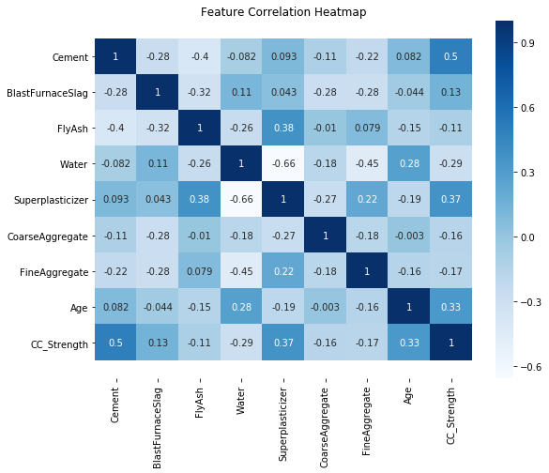
Figure 3.1 Feature Correlation Heatmap

We can observe a high positive correlation between Compressive Strength (CC_Strength) and Cement. This is true because strength concrete indeed increases with an increase in the amount of cement used in preparing it. Also, Age and Super Plasticizer are the other two factors influencing Compressive Strength.
There are other strong correlations between the features ----- A strong negative correlation between Super Plasticizer and Water and the Positive correlations between Super Plasticizer and Fly Ash, Fine Aggregate.
3.4.1.1 Pair Plot
These correlations are useful to understand the data in detail, as they give an idea about how a variable is affecting the other. We can further use a pair plot in seaborn to plot pair wise relations between all the features and distributions of features along the diagonal.
sns.pairplot(data)
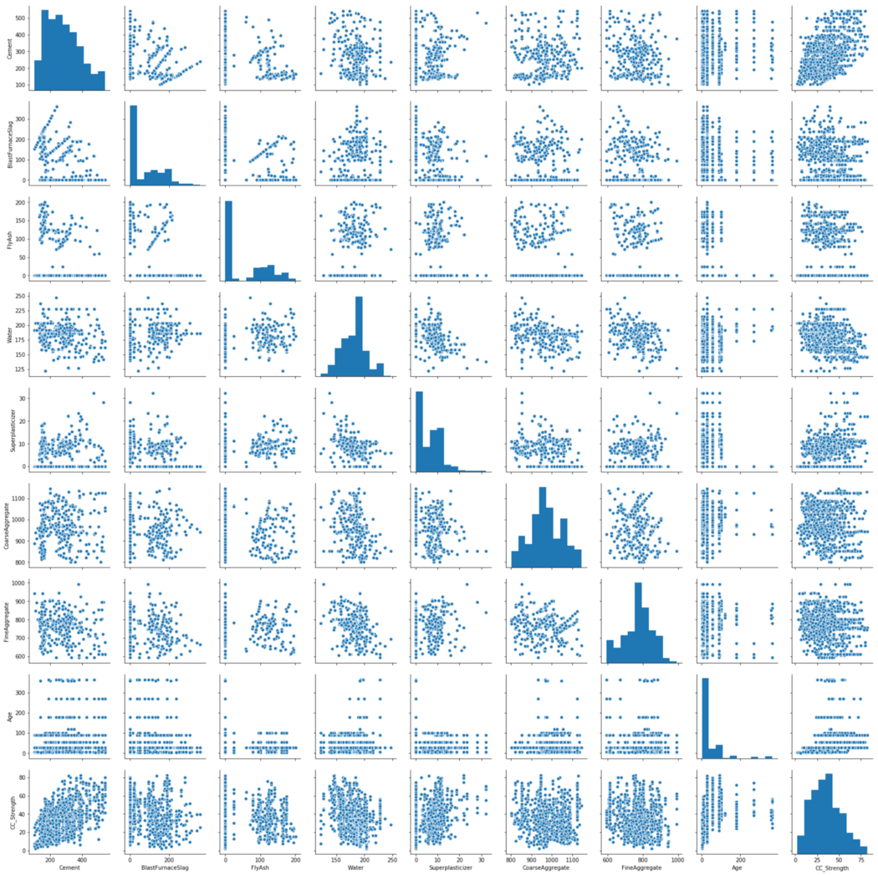
Figure 3.2 Pair plot representation of correlations between all the features
3.4.1.2 Scatter plot-1
We can plot scatter plots between CC_Strength and other features to see more complex relations.
sns.scatterplot(y="CC_Strength", x="Cement", hue="Water",size="Age", data=data, ax=ax, sizes=(50, 300))

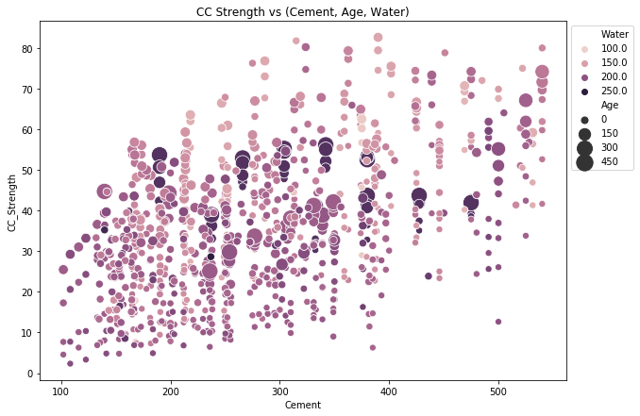
Figure 3.3 Scatter plot for CC_Strength vs (Cement, Age, Water)
The observations we can make from this plot,
- Compressive strength increases as the amount of cement increases, as the dots move up when we move towards right on the x-axis.
- Compressive strength increases with age (as the size of dots represents the age), this not the case always but can be up to an extent.
- Cement with less age requires more cement for higher strength, as the smaller dots are moving up when we move towards right on the x-axis.
- The older the cement is the more water it requires, can be confirmed by observing the colour of the dots. Larger dots with dark colour indicate high age and more water.
- Concrete strength increases when less water is used in preparing it since the dots on the lower side (y-axis) are darker and the dots on higher-end (y-axis) are brighter.
3.4.1.3 Scatter plot-2

sns.scatterplot(y="CC_Strength", x="FineAggregate", hue="FlyAsh",
size="Superplasticizer", data=data, ax=ax, sizes=(50, 300))

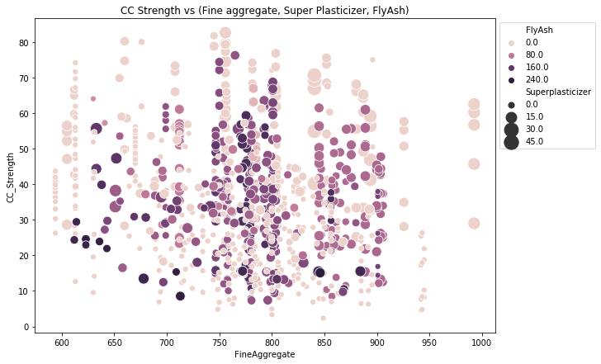
Figure 3.4 Scatter plot for CC Strength vs (Fine aggregate, Super Plasticizer, Fly Ash)

The observations we can make from this plot,
- Compressive strength decreases Fly ash increases, as darker dots are concentrated in the region representing low compressive strength.
- Compressive strength increases with Super plasticizer since larger the dot the higher they are in the plot.
We can visually understand 2D, 3D and max up to 4D plots (features represented by colour and size) as shown above, we can further use row-wise and column-wise plotting features by seaborn to do further analysis, but still, we lack the ability to track all these correlations by ourselves. For this reason, we can turn to Machine Learning to capture these relations and give better insights into the problem.

3.5 Importing Modules
For further process we have to import some important modules present in python:
# importing pandas
import pandas as pd
#importing numpy
import numpy as np
#importing matplotlib
import matplotlib.pyplot as plt
#importing seaborn
import seaborn as sb

3.6 Reading data
Generally, we use a dataset in the form of a CSV file, for reading this CSV file we will use the panda’s library, let’s see:

df = pd.read_csv(' Concrete_data.csv ')
df.head()

Table 3.1 Concrete Dataset
S.No. | Cement | Slag | Flyash | Water | Superplasticizer | Course Aggregate | Fine Aggreagate | Age | csMPa
0 | 540.0 | 0.0 | 0.0 | 162.0 | 2.5 | 1040.0 | 676.0 | 28 | 79.99
1 | 540.0 | 0.0 | 0.0 | 162.0 | 2.5 | 1055.0 | 676.0 | 28 | 61.89
2 | 332.5 | 142.5 | 0.0 | 228.0 | 0.0 | 932.0 | 594.0 | 270 | 40.27
3 | 332.5 | 142.5 | 0.0 | 228.0 | 0.0 | 932.0 | 594.0 | 365 | 41.05
4 | 198.6 | 132.4 | 0.0 | 192.0 | 0.0 | 978.4 | 825.5 | 360 | 44.30

3.7 Data Pre-processing
Before we fit machine learning models on the data, we need to split the data into train, test splits. The features can be rescaled to have a mean of zero and a standard deviation of 1 i.e. all the features fall into the same range.

3.7.1Study Dataset
describe() -method to calculate the various calculation of each data point in the feature.
df.describe()

Table 3.2 Description of concrete data set
 | Cement | Blast Furnace Slag | Fly Ash | Water | Superplasticizer | Coarse Aggregrate | Fine Aggregate | Age | Compressive Strength
count | 1030.000000 | 1030.000000 | 1030.000000 | 1030.000000 | 1030.000000 | 1030.000000 | 1030.000000 | 1030.000000 | 1030.000000
mean | 281.167864 | 73.895825 | 54.188350 | 181.567282 | 6.204660 | 972.918932 | 773.580485 | 45.662136 | 35.817961
std | 104.506364 | 86.279342 | 63.997004 | 21.354219 | 5.973841 | 77.753954 | 80.175980 | 63.169912 | 16.705742
min | 102.000000 | 0.000000 | 0.000000 | 121.800000 | 0.000000 | 801.000000 | 594.000000 | 1.000000 | 2.330000
25% | 192.375000 | 0.000000 | 0.000000 | 164.900000 | 0.000000 | 932.000000 | 730.950000 | 7.000000 | 23.710000
50% | 272.900000 | 22.000000 | 0.000000 | 185.000000 | 6.400000 | 968.000000 | 779.500000 | 28.000000 | 34.445000
75% | 350.000000 | 142.950000 | 118.300000 | 192.000000 | 10.200000 | 1029.400000 | 824.000000 | 56.000000 | 46.135000
max | 540.000000 | 359.400000 | 200.100000 | 247.000000 | 32.200000 | 1145.000000 | 992.600000 | 365.000000 | 82.600000

sns.distplot(df['Compressive Strength'])

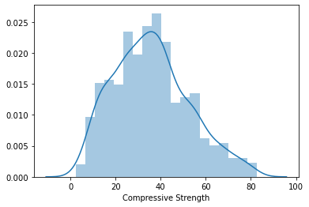
Figure 3.5 Dist plot for Compressive strength

3.7.2 Dividing Dependent and Independent Variables
Before starting model building we have to divide the dataset into two parts,
- Independent variables contain a list of those variables in which concrete quality is dependent.
- The dependent variable is that variable that is dependent on other variables’ values.
# independent variables
x = df.drop(['csMPa'],axis=1)
# dependent variables
y = df['csMPa']
In this program, x contains the list of independent variables, and y contains the dependent variable in this case:
- Independent variables are cement, flyash, water, Superplasticizer, coarse aggregate, fineaggregate, age.
- dependent variable is the only csMPa

3.7.3 Splitting the data
Now we use the scikit-learn module train_test_split, which is used for splitting the training and testing parts.
# importing train_test_split
from sklearn.model_selection import train_test_split
xtrain,xtest,ytrain,ytest= train_test_split(x,y,random_state=0)

After reading the dataset we have to extract information from the data, for that we use the certain function:
df.info()
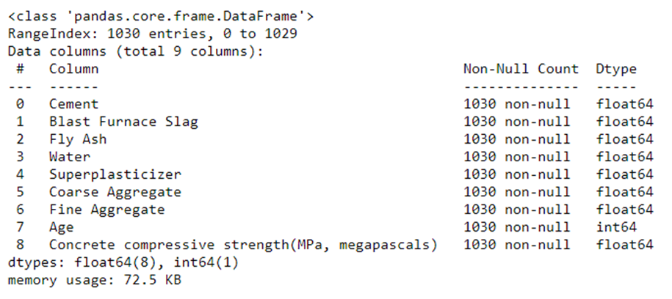e 1030 non-null int64
Figure 3.6 Concrete dataset info

Here we notice that the count of null values in each feature and see what is the data type of features present in the dataset.

3.7.4 Handling Null values
Now, we handle the null values that are present in the dataset for better accuracy,
df.isnull().sum()
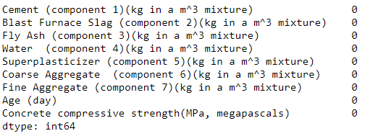
Figure 3.7 Null data info

3.8 Model Building
After preparing the data, we can fit different models on the training data and compare their performance to choose the algorithm with good performance. Machine learning consists of algorithms that can automate analytical model building using algorithms that iteratively learn from data. In this step, we applying several machine learning algorithms to training data. As this is a regression problem, we can use RMSE (Root Mean Square Error) and R² score as evaluation metrics.

3.8.1 Linear regression:

Linear Regression (LR) Linear regression is an old method to evaluate the correlation between two or more features. After deciding the relationship between features (input) and target (output), the learning process will be run to minimize the loss function value (like Mean Squared Error). The parameters that minimize the loss function are exactly the optimal parameters for the regression. Due to its simplicity, the accuracy of this model is not high. The general form of a multiple linear regression model is given in Equation (1) below :
yˆ = a0 + m ∑ j = 1 ajXj (1)
where yˆ is the predicted result, Xj are the features (input) of the dataset, and a0, a1, . . . , am are the parameters to train. In this study, this model is employed to fit multiple linear equations that relate the compressive strength and the given features.
According to previous research, the relation between features and compressive strength is complex and nonlinear. Therefore, in order to improve the prediction accuracy of LR model, polynomial features are created using original features with different polynomial degrees.
from sklearn.linear_model import LinearRegression,

model=LinearRegression()
model.fit(X_train,y_train)
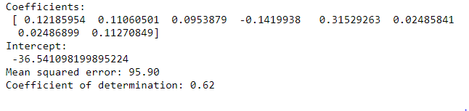
Figure 3.8 Metrics of the model
Now, we plot a scatter plot and fit the line for checking the prediction values,
plt.figure(figsize=[17,8])
plt.scatter(y_pred,ytest)
plt.plot([ytest.min(), ytest.max()], [ytest.min(), ytest.max()], color='red')
plt.xlabel('predicted')
plt.ylabel('orignal')
plt.show()

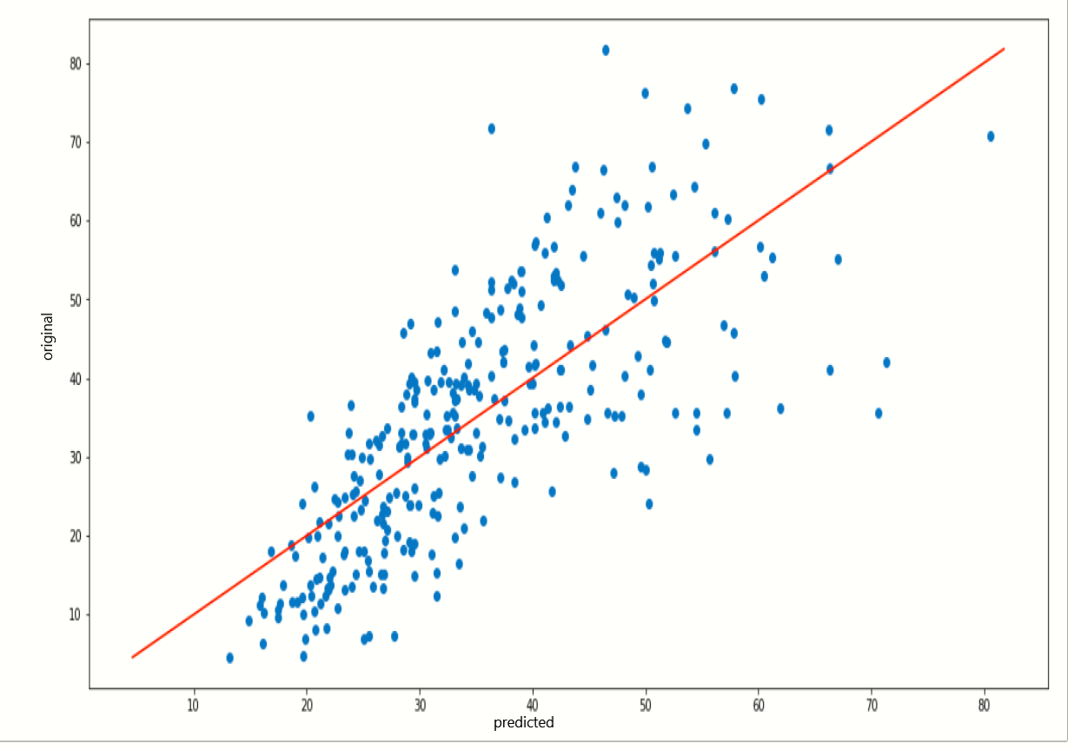
Figure 3.9 Scatter plot for original vs predicted values

You can see how the line is partially fit our predicted data points.

3.9 Saving the Model
Now, we save our machine learning model using pickle.
import pickle
file = 'concrete_strength'
save = pickle.dump(rnd,open(file,'wb'))

CHAPTER 4
RESULTS AND DISCUSSION, PERFORMANCE ANALYSIS

4.1 Outcomes:
A new model for prediction of compressive strength from an early day test result is presented. The proposed model makes use of the strength gaining characteristics of normal weight concrete as its base. Two groups of test data are used to develop the model while its performance is checked with four groups of test results. Concrete made with two different types aggregates viz. stone aggregate and local (brick chips) aggregates are included within the four groups considered. For analysis and model purpose stone aggregate concrete data are used (Group-1 & Group-2). Each data set, which corresponds to a particular concrete consists strength results at different ages. Performance evaluation is done with different data groups and the prediction is made for a particular day for which the test results are available.

4.1.1 Predicted Values vs Original Values
Now, we take a compression between the predicted values of the dependent variable csMPa and the original values of variable csMPa.
Y_pred = list(rnd.predict(y_test))
df1 = {'Actual Strength': y_test, 'Predicted Strength': y_pred}
#creating new dataframe
pd.DataFrame(df1)

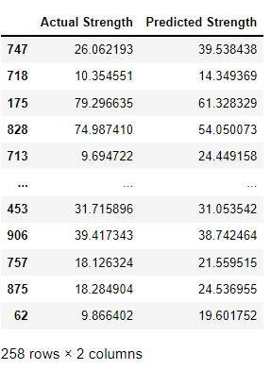
Figure 4.1 Actual Strength vs Predicted Strength

Before we look at the results, let's see how each model values each feature by visualising the coefficients

def plot_coef (models):

coefs = {}
rows = []
fig, ax = plt.subplots(figsize=(16,8))
offset = 0
width = 0.23
x = np.arange(len(X.columns))

# Creating a neat table to view
for model in models:
coefs[type(model).__name__] = model.coef_

coefs_table = pd.DataFrame.from_dict(coefs, orient='index')
coefs_table.columns = X.columns

# Using the table to create a chart
for i in range(len(models)):
increment = width
ax.bar(x - width + offset, coefs_table.iloc[i], width=width, label=type(models[i]).__name__)
offset = offset + increment

ax.set_ylabel('Coefficient')
ax.set_xlabel('Features')
ax.set_title('Feature Coefficients')
ax.set_xticks(x)
ax.set_xticklabels(X.columns)
ax.legend()

return coefs_table

models = [model]

coefs_table = plot_coef(models)

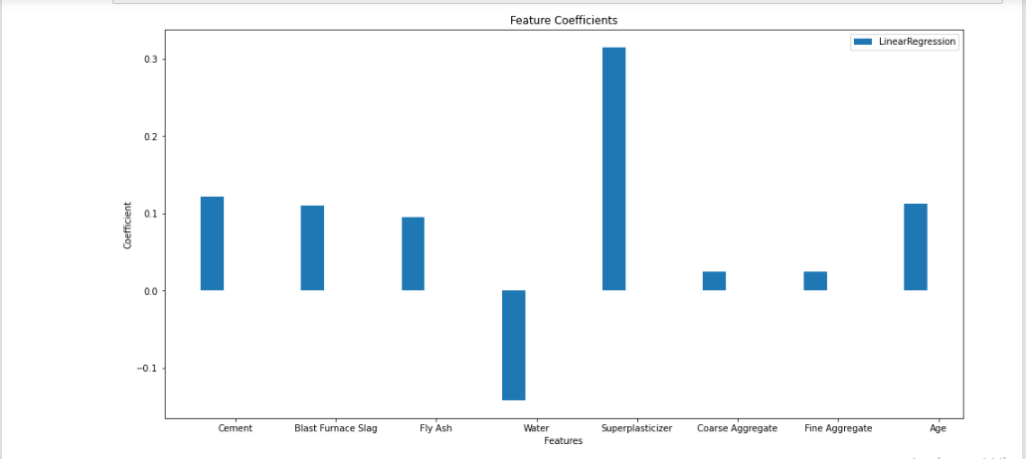
Figure 4.2 Comparison of Feature Coefficients Graph

Table 4.1 Final Feature Coefficients
 | Cement | Blast Furnace Slag | Fly Ash | Water | Superplasticizer | Coarse Aggregrate | Fine Aggregate | Age
LinearRegression | 0.12185954 | 0.11060501 | 0.0953879 | -0.1419938 | 0.31529263 | 0.02485841 | 0.2486899 | 0.11270849

4.2 Performance Analysis
The performance measuring statistical parameters like Root Mean Square Error, Mean Average Error, percent Efficiency and ratio of prediction to actual values [RMSE, MAE, EF (%), and Pi/Ai] are used to check the efficiency of the proposed model for every group of data sets.

4.2.1 Scoring metrics
Although all of our models have performed similarly, it depends on which scoring metric you look at that determine the overall winner. Let's explore the different scoring metrics.

4.2.1.1 Root Mean Square Error (RMSE)
RMSE is the square root of the error function that the regression algorithms are trying to reduce. It is an absolute measure of how well the model fits the data.

4.2.1.2 Mean Absolute Error (MAE)
Similarly to RMSE, MAE looks at the sum of the value of errors. However, since we are not squaring the value and instead taking the absolute value, it is more forgiving to large prediction errors.

4.2.1.3 R Square
R Square measures how much variability in a dependent variable can be explained by the model. It is a good metric to determine the fit on dependent variables. But, it does not take into consideration over-fitting.

Table 4.2 Scoring Metrics
 | RMSE | R2
LinearRegression | 95.90 | 0.62

CHAPTER 5
SUMMARY AND CONCLUSIONS
Using machine learning models we have simulated the compressive strength of concrete using countless combinations of ingredients and aging process. Through EDA we have discovered that cement, age and super plasticizer have a positive impact on the overall strength. Water is found to have a negative impact, but is often present in older concrete due to the curing processes. After utilising linear regression models it has become evident that blast furnace slag is much more important than previously thought and super plasticizer the opposite. These insights are not intuitive and could be profound and beneficial in a business context.
All of our linear regression models performed similarly in the scoring metrics and would all be suitable in a production environment for making further predictions and testing. To improve, perhaps decision trees and ensemble methods could be used to increase the prediction score. There is a clear opportunity for digital simulation to reduce wait time and total number of combinations. With the data set acquired we can learn about the relations between variables and develop a predictive model. Highlighting potentially optimal combinations to then be used in physical testing will provide enormous benefit and significantly reduce labour and testing costs
Earlier and accurate estimates of concrete strength are valuable to the construction industry. The presence of such model would possibly obtain the hard balance and equality between controlling the quality (quality control process) and economics (saving time and expense, i.e., this model could be used in construction to make the necessary adjustments on mix proportion used, to avoid situations where, concrete does not reach the required design strength or by avoiding concrete that is unnecessarily strong.
This methodology allows a fast and accurate prediction of values ​​for compressive strength on site. Common methods for estimation of in place strength requires extensive use of curing of mortar cubes at constant temperatures or the use of databases containing a large number of compressive strength values ​​made at many ages and cured at different temperatures.
These databases have to be fed with a statistical relevant number of data before a reliable estimation of the strength can be made. All of these methods require many hours of lab and field time for testing, collecting and analyzing data. Furthermore, the existing variables in the model yielded good reasonable results. Also, it is not preferred to load the prediction model with large number of variables, because it is preferred to use a model with lesser number of variables with the higher possible accuracy to assure the rapid and easy use of the model.

REFERENCES:
1. M. F.M. Zain and S. M. Abd, “Multiple Regression Model for Compressive Strength Prediction of High-Performance Concrete”, Journal of Applied Sciences, Vol. 9, Year 2009, Pages 155-160
2. Nand Kumar, Vishal Naranje and Sachin Salunkhe, “Cement strength prediction using cloud-based machine learning techniques”, Journal of Structural Integrity and Maintenance, VOL. 5, No.4,Year 2020, Pages 244–251
3. Jee Namyong, Yoon Sangchun & Cho Hongbum, “Prediction of Compressive Strength of In-Situ Concrete Based on Mixture Proportions”, Journal of Asian Architecture and Building Engineering, Vol. 3, Year 2018, Pages 9-16

4. M.F.M.ZainªM.SafiuddinªK.M.Yusofª, “A study on the properties of freshly mixed high performance concrete”, Cement and Concrete Research, Vol. 29, Year 1999, Pages 1427-1432

5. Rachna Aggarwala, Maneek Kumarb , R.K. Sharmac , and M.K. Sharma, “Predicting Compressive Strength of Concrete”, International Journal of Applied Science and Engineering, Volume: 13, No. 2, Year 2015, Pages 171-185
6. M. Timur Cihan, “Prediction of Concrete Compressive Strength and Slump by Machine Learning Methods”, Advances in Civil Engineering, Volume 2019, Year 2019, Pages 1-11
7. Palika Chopra , Rajendra Kumar Sharma and Maneek Kumar, “Predicting Compressive Strength of Concrete for varying workability using Regression Models”, International Journal of Engineering & Applied Sciences (IJEAS), Vol.6, Year 2014, Pages 10-22
8. K. Kaviya1, J. Premalatha2, “Prediction of Compressive Strength of High Performance Concrete using Artificial Neural Network (ANN) Models”, International Research Journal of Engineering and Technology (IRJET), Vol. 06, Year 2019, Pages 1378-1387
9. Palika Chopra Dr. R. K. Sharma Dr. Maneek Kumar, Regression Models for the Prediction of Compressive Strength of Concrete with & without Fly ash, International Journal of Latest Trends in Engineering and Technology (IJLTET), Vol. 3, Year2014, Pages 400-406
10. P. Silva, G. Moita and V. Arruda, “Machine Learning techniques to predict the Compressive Strength of Concrete”, International Journal of Numerical Methods for Calculation and Design in Engineering (RIMNI), Vol. 36, Year 2020, Pages 1-48
11. Ahsanul Kabir, Monjurul Hasan, and Md. Khasro Miah, “Strength Prediction Model for Concrete”, International Journal on Civil and Environmental Engineering, Vol. 2, No. 1, Year 2013, Pages 14-19.
12. Vahid. K. Alilou & Mohammad. Teshnehlab, “Prediction of 28-day compressive strength of concrete on the third day using artificial neural network”, International Journal of Engineering (IJE), Volume 3, Year 2010, Pages 565-576
13. Fabian Pedregosa, Gael Varoquaux, Alexandre Gramfort, Vincent Michel, Bertrand Thirion, “Scikit-learn: Machine Learning in Python”, Journal of Machine Learning Research, Vol. 12, Year 2011, Pages 2825-2830
14.Metwally abd Allah, Abd Elaty, “Compressive strength prediction of Portland cement concrete with age using a new model”, HBRC Journal, vol. 10, No. 2, Year 2014, Pages 145-155
15. S.Chithraa, S.R.R. SenthilKumar, K.Chinnaraju, F. Alfin Ashmita, “A comparative study on the compressive strength prediction models for High Performance Concrete containing nano silica and copper slag using regression analysis and Artificial Neural Networks”, Construction and Building Materials, Volume 114, Year2016, Pages 528-535

16. Phijo J Cherickal, Vidhya V Kumar, Ranjini Mariam Philipose, Shailesh S, Tiji Thomas, “Compression Strength Prediction Using Machine Learning Techniques”, International Journal of Advanced Trends in Computer Science and Engineering, Vol. 10, No.1, Year 2021, Pages 301-307

17. YangYuaWenguiLiaJianchunLiaThuc N.Nguyena, “A novel optimised self-learning method for compressive strength prediction of high performance concrete”, Construction and Building Materials, Volume 184, Year 2018, Pages 229-247
18. I-Cheng Yeh, "Modeling of strength of high performance concrete using artificial neural networks," Cement and Concrete Research, Vol. 28, No. 12, Year 1998, Pages 1797-1808.
19. I-Cheng Yeh, "Modeling Concrete Strength with Augment-Neuron Networks", Journal of Materials in Civil Engineering, Vol. 10, No. 4, Year 1998, Pages 263-268.
20. I-Cheng Yeh, "Design of High Performance Concrete Mixture Using Neural Networks", Journal of Computing in Civil Engineering, Vol. 13, No. 1, Year 1999, Pages 36-42.
21. I-Cheng Yeh, "Prediction of Strength of Fly Ash and Slag Concrete By The Use of Artificial Neural Networks", Journal of the Chinese Institute of Civil and Hydraulic Engineering, Vol. 15, No. 4, Year 2003, Pages 659-663.
22. I-Cheng Yeh, Chung Hua, "A mix Proportioning Methodology for Fly Ash and Slag Concrete Using Artificial Neural Networks", Journal of Science and Engineering, Vol. 1, No. 1, Year 2003, Pages 77-84.
23. I-Cheng Yeh, "Analysis of strength of concrete using design of experiments and neural networks," Journal of Materials in Civil Engineering, Vol.18, No.4, Year 2006, Pages 597-604.
24. Ahsanul Kabir, Md Monjurul Hasan, Khasro Miah, “ Strength Prediction Model for Concrete”, Int. J. on Civil and Environmental Engineering, Vol. 2, No. 1, Year 2013, Pages 14-19

25. Iqrar Hussain and Adeel Ehsan and Umar A. Rehman and Suraya Mohd Tahir, “Prediction of Compressive Strength of High Strength Concrete Using Multiple Linear Regression Equation (MLRE) and Numerical model”, Volume 05, Year 2020, Pages 26-36

26. Kiambigi, Maina, Gwaya, A.O, Koteng, D.O, “Concrete Strength Prediction using MultiLinear Regression Model: A case study of Nairobi Metropolitan”, International Journal of Soft Computing and Engineering (IJSCE), Volume 8, Year 2019, Pages 11-20.

27. Jui-Sheng Chou, Chih-Fong Tsai, Anh-Duc Pham, Yu-Hsin Lu,
“Machine learning in concrete strength simulations: Multi-nation data analytics”,
Construction and Building Materials, Volume 73, Year 2014, Pages 771-780

28. Concrete Testing:
http://www.civilengineeringforum.me/compressive-strength-test-of-concrete/

29.Sci-kitlearn: https://scikitlearn.org/stable/tutorial/machine_learning_map/index.html
30. Case Study on Concrete Strength Prediction:
Concrete strength prediction case study in python - Thinking Neuron
31. Data Analysis in Python:
A Beginner’s Guide to Data Analysis in Python | by Natassha Selvaraj | Towards Data Science

APPENDIX

- SCREENSHOTS:

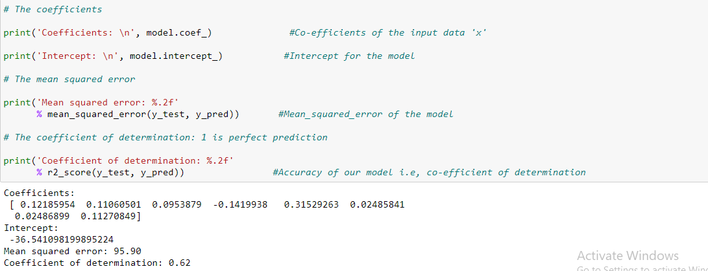

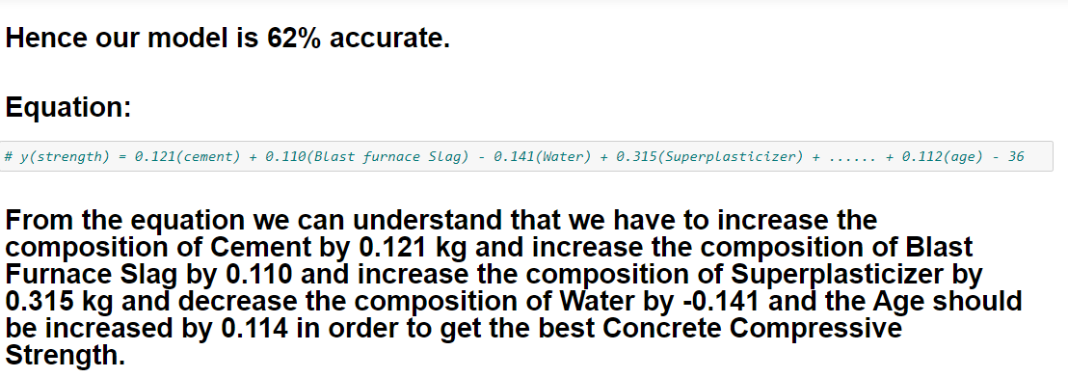

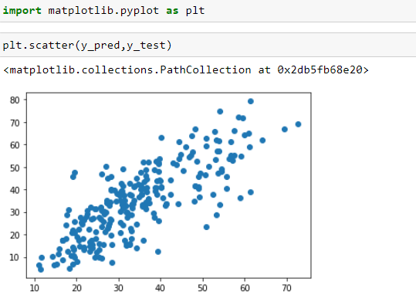

- SOURCE CODE:
import pandas as pd
import numpy as np

df = pd.read_excel(‘C:\\Users\\balad\\Onedrive\\Concrete_Data.xls’)
df #dataframe

x = df.iloc[:,0:8]
x #input data

y = df.iloc[:,8]
y #output data

from sklearn.model_selection import train_test_split

#splitting the dataset into training and testing datasets
x_train, x_test, y_train, y_test = train_test_split(x,y,random_state=0)

print(x_train.shape)
#75% of the actual data is given for training the model

print(x_test.shape)
#Remaining 25% of the actual data is given for testing the model

from sklearn.linear_model import LinearRegression
model = LinearRegression()
#using the LinearRegression model

model.fit(x_train,y_train)
#creating a model and training it using x_train and y_train

y_pred = model.predict(x_test)
y_pred #predicted values
y_test #actual values

from sklearn.metrics import mean_squared_error, r2_score

# The coefficients

print('Coefficients: \n', model.coef_)
#Co-efficients of the input data 'x'

print('Intercept: \n', model.intercept_)
#Intercept for the model

# The mean squared error

print('Mean squared error: %.2f' % mean_squared_error(y_test, y_pred))
#Mean_squared_error of the model

# The coefficient of determination: 1 is perfect prediction

print('Coefficient of determination: %.2f' % r2_score(y_test, y_pred))
#Accuracy of our model i.e, co-efficient of determination

